Sumit Vadaviya

Camunda BPM Expert, Corporate Trainer

Email : sumit.vadaviya@trainosoft.com

I

n this session we will try get overview of BPM.

**What BPM is ?**

Business Process Management (BPM) is a discipline involving any combination of modeling, automation, execution, control, measurement and optimization of business activity flows, in support of enterprise goals, spanning systems, employees, customers and partners within and beyond the enterprise boundaries.

* **BPM** is a discipline; it is a practice; it is something you do.
* Business stems from the state of being busy, and it implies commercially viable and profitable work. A business exists to provide value to customers in exchange for something else of value.

BPM Overview

* **Process** means a flow of business activities and seeing those activities as connected toward the achievement of some business transaction. Flow is meant loosely here: the order of execution may or may not be strictly defined.
* A person doing BPM must consider a process at the scope of interrelated business activities which holistically cooperate to fulfil a business objective. This is the key difference from a functional view of business where each function might be optimised independent of the other functions. In a complex system like a business, it is well known that local optimisation of part of the system will rarely lead to good overall results. A BPM practitioner must consider the metrics of the entire system when evaluating a specific process.
* **Modeling** means that they would identify, define, and make a representation of the complete process to support communication about the process. There is no single standard way to model, but the model must encompass the process.
* **Automation** refers to the work that is done in advance/automatic to assure the smooth execution of the process instances.
* **Execution** meaning that instances of a process are performed or enacted, which may include automated aspects. Conceptually, the process instance executes itself, following the BPM practitioner’s model.
* **Control** means that the there is some aspect of making sure that the process follows the designed course. This can be strict control and enforcement, or it might be loose control in the form of guidelines, training, and manual practices.
* **Measurement** means that effort is taken to quantitatively determine how well the process is working in terms of serving the needs of customers.
* **Optimisation** means that the discipline of BPM is an ongoing activity that builds over time to steadily improve the measures of the process. Improvement is relative to the goals of the organization, and ultimately in terms of meeting the needs of customers.
* **Enterprise** is used here simply to mean a business organization; any organization where people are working together to meet common goals; it does not need to be exceptionally large, and it does not need to be for profit.
* The mention of enterprise goals is included here to emphasize that BPM should be done in the context of the goals of the enterprise, and not some small part of it. This might seem a bit redundant in one sense: any improvement of a process must be an improvement in terms of the enterprise goals – anything else would not be called an improvement.
* Within and beyond the enterprise boundaries recognizes that the enterprise is part of a larger system. Customers are part of the business process. Their interaction, along with those of employees should be considered as part of the end-to-end interaction.

**Business Process**

* Business processes are a sequence of business activities done by business users and business applications (company or third-party systems) to achieve a business goal for the purpose of a specific increase in value from the business' perspective.
* From a developer-friendly perspective, we can think of business as a particular domain or context, or group of contexts.
* It could be easily exchanged in domain, field, company, company unit, and any lingo that specifies a defined area of work.
* Business processes need to be evaluated, analyzed, designed, modeled, and validated by people who understand the domain where those processes belong.
* Since there are different business roles within a company, each should know a different perspective of the same process.
* It is important to notice that the goal of business processes is tightly associated to the business goals, objectives, and strategies.

**BPM Discipline**

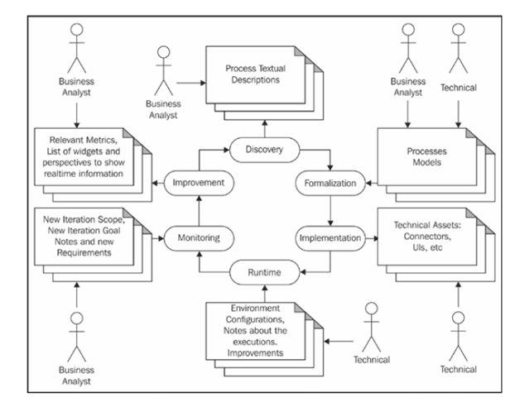

**BPM Stage 1 – Discovering your business Processes**

* Discovery of new processes is started most of the time by business analysts. It involves a certain level of knowledge engineering; a branch of requirement gathering involved in correctly merging different knowledge representation strategies, such as business rules, process definitions, and so on, with the knowledge from domain experts.
* This stage has added weight when you're implementing the first iteration of the BPM cycle, which is choosing a starting point to demonstrate the importance of BPM for the business.
* It is important to take time to evaluate the learned lessons at the end of each of the iterations.
* After identifying a goal to build a process around, this stage consists of performing interviews with business experts, representatives of operation, and anyone who is involved (or that should be involved) in the process.

**BPM stage 2 – formalizing your new processes**

* When the business process, its owner, and the business goal have been identified, we can start working in a formal, unambiguous representation of the business process.
* In this stage, business analysts trained in BPMN 2.0 will model the business processes. They should choose the level of accuracy of the process representation, depending on the time and information available for this stage.

**BPM stage 3 – implementing your technical assets**

* In the third stage, the Development team works with the Business Analyst team to add all the technical details that will allow the process to run. This will act as common ground for exchange of ideas, improvement, formalized contract between areas, and also as documentation of what is being done.
* For that reason, it is important to keep it safe, versioned, and centralized. For this purpose, we usually set up a knowledge repository to store them.

**BPM stage 4 – runtime**

* At runtime, we will put our business process and assets in a production environment. This is the point where we start training users to understand how to interact with the activities of the business processes.
* During the first iteration of this stage, the runtime should be restricted to a few simple processes and to a small well known group of users.
* This stage is when we actually start detecting how our processes behave in the real world.

**BPM stage 5 – monitoring**

* We need to start concerning ourselves with the information that runtime gives us. Process execution can send many events to components that are external to the actual runtime. Those components can be fed to a dashboard-like tool to allow us to monitor process execution and actual performance metrics. This is a stage where the process simulation from stage 2 can be validated, and notes of the actual estimations should be taken for improvement of process simulations in the next iteration.
* Monitoring is about real-time information analysis and display, but it should also be about flexibility. You might need to add new sources and types of metrics as fast as possible to measure them within the runtime.

**BPM stage 6 – improvements**

* We have our process runtime running to provide us with relevant information about the processes' execution.
* We might also have learned about exceptional situations in our processes that weren't considered at first and their ad hoc solutions. We now know how to simulate our processes better.
* In this stage, we take care of business changes that need to be reflected in our business processes. All their improvements, along with the planning generated from the learned lessons, is used as an input for the next iterations—starting again from stage 1 and completing the BPM cycle.